**Fire Base**

How to add the firebase manually

1. First create the project in firebase.
2. Register the app in the firebase website.
3. Then we have to add some dependences which will change with time.
4. Or some gradle changes which we have to make wrt documentation.

Both at the app level and the project level.

In the data base the work will be going on the key value pairs just like the json files.

For authentication part we have to add the dependences we can use the

“bom” implementation which will help us to use the “auth” only implementation which help for better upgradation of the application.

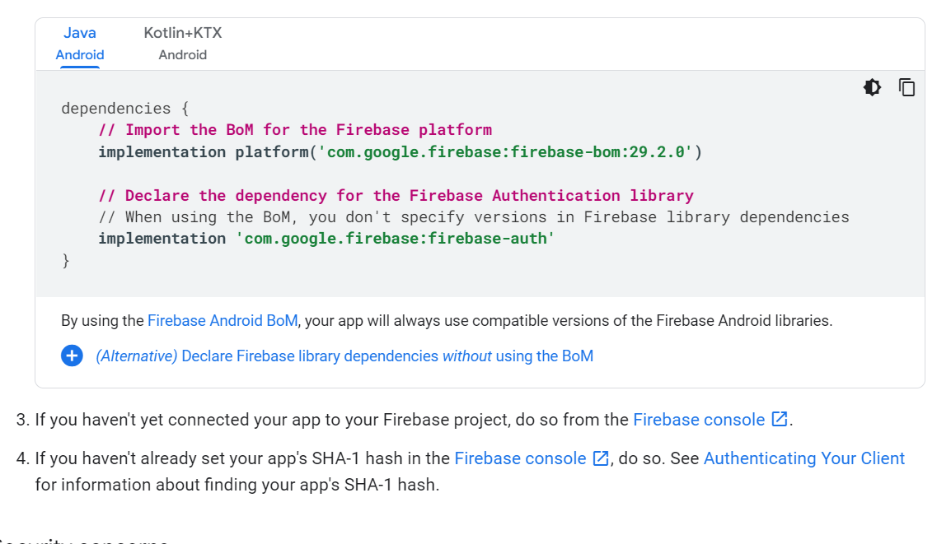

How to take the input of the image or any other file in your app and store it into the database: -

private ActivityResultLauncher<String> launcher;

binding.button.setOnClickListener(new View.OnClickListener() {  
 @Override  
 public void onClick(View view) {  
 launcher.launch("image/*");  
 }  
});

launcher = registerForActivityResult(new ActivityResultContracts.GetContent(),  
 new ActivityResultCallback<Uri>() {  
 @Override  
 public void onActivityResult(Uri result) {  
 binding.image.setImageURI(result);

…….

these two code blocks helps to take the input from the files of any type.

Now we will see that how to send the notification to the users: -

For that we can use both firebase cloud messaging and One Signal but in onesignal we have additional features than firebase.